**TELEMEDICINE PROJECT OUTPUT**

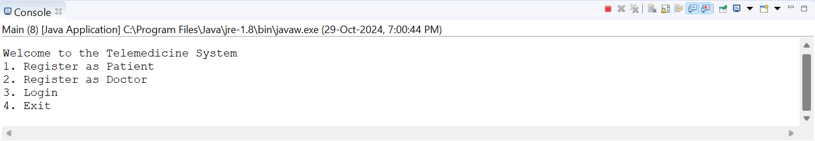

Register as patient

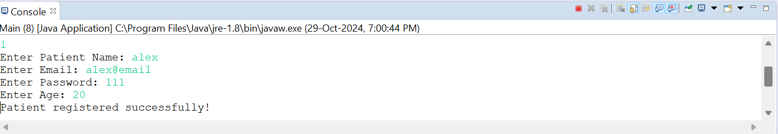

Register as doctor

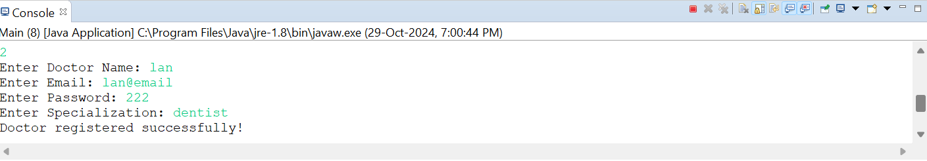

Login as patient

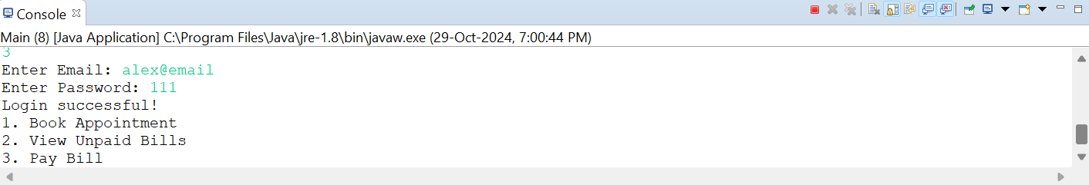

Book appointment

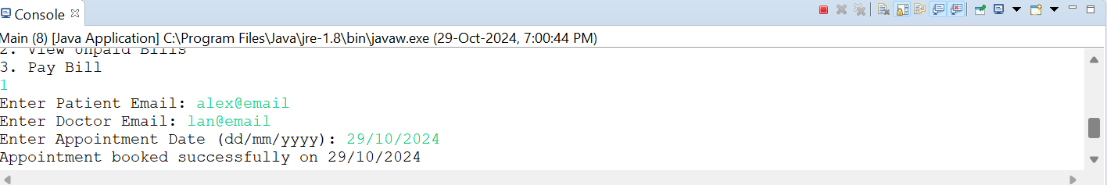

View unpaid bills

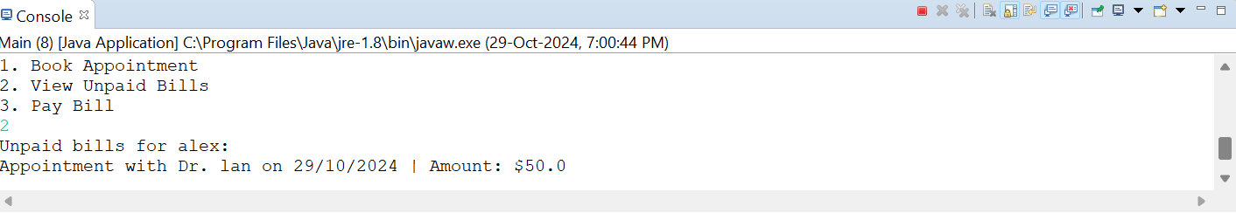

Pay bill

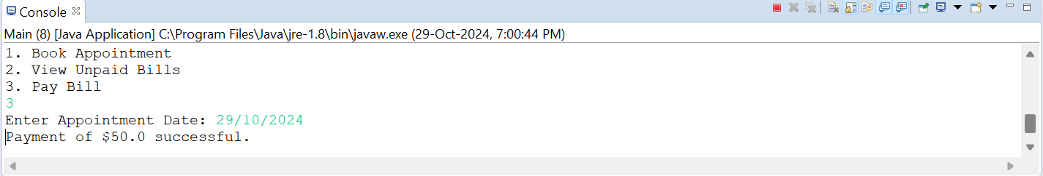

Login as doctor

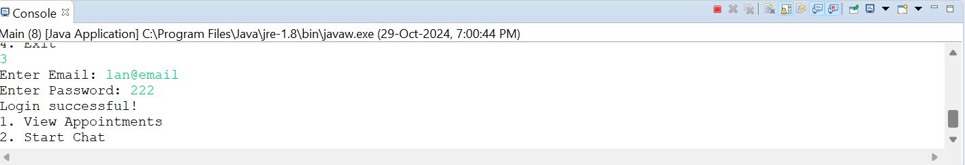

Start chat

